EXPERIMENT 19
Determination and plotting of Antenna Efficiency.
Aim:
To determine and plot Antenna Efficiency and to Estimate the efficiency based on radiated and input power.
Software required:
• SCILAB version 6.0.1
Program:

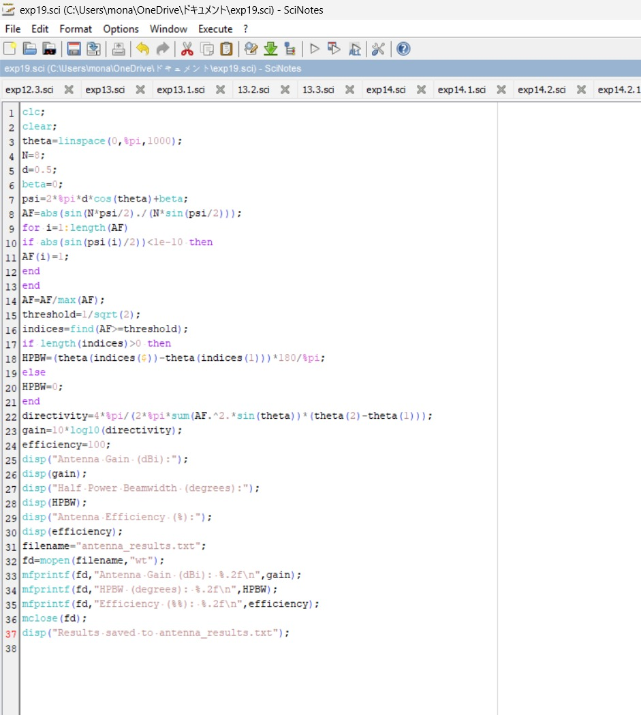
Output:
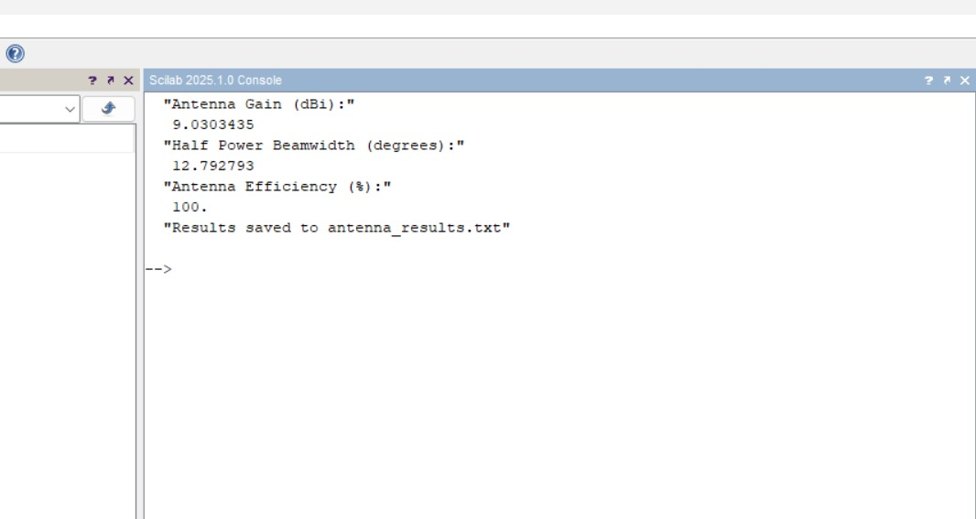
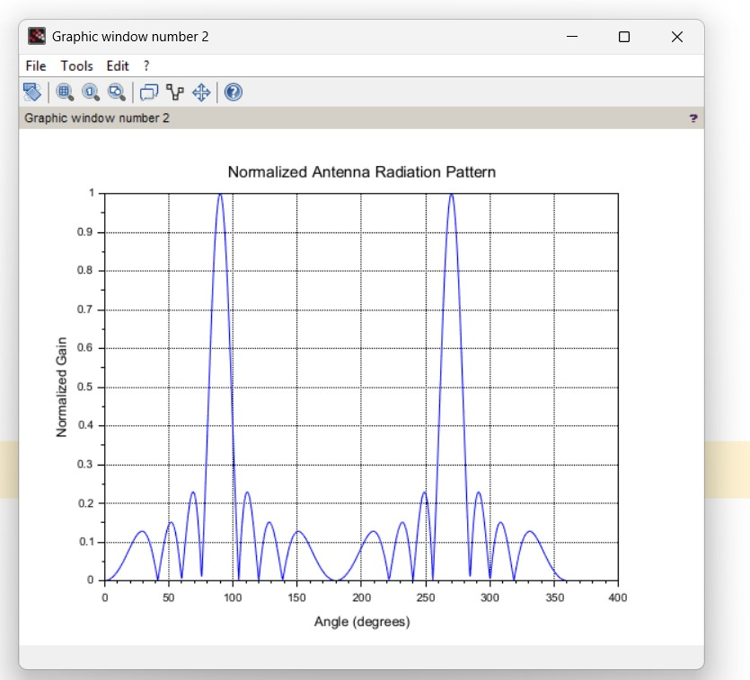
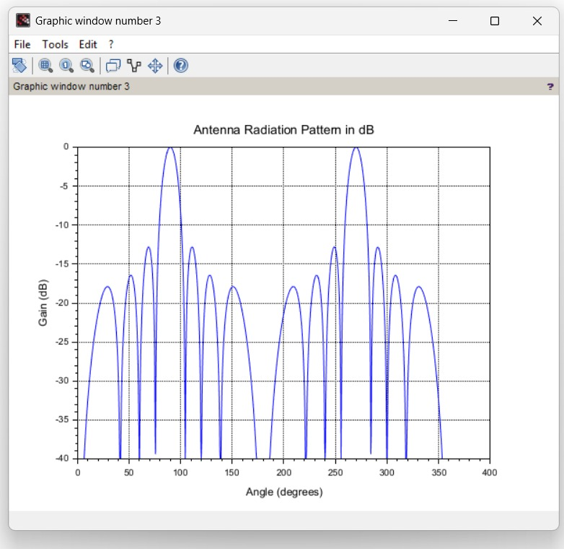

Program:
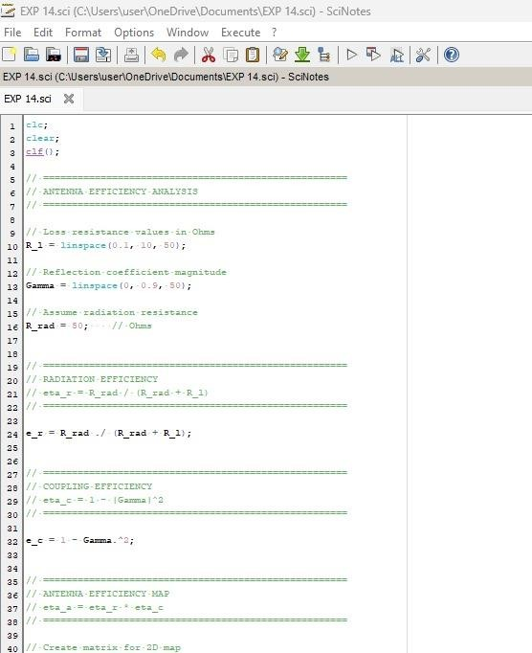
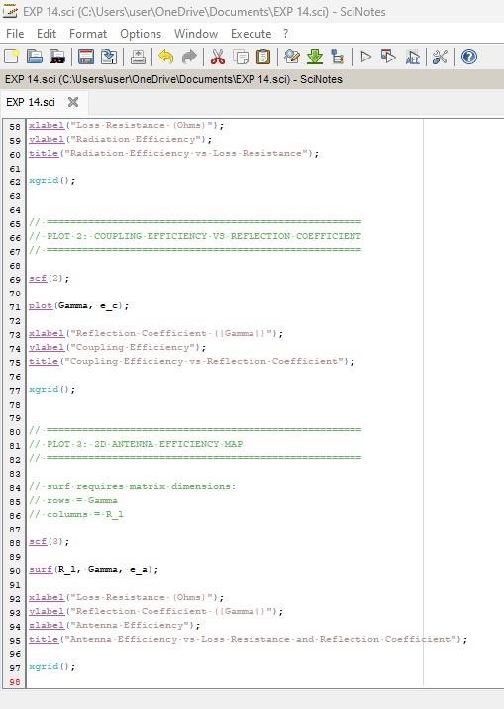
Output:
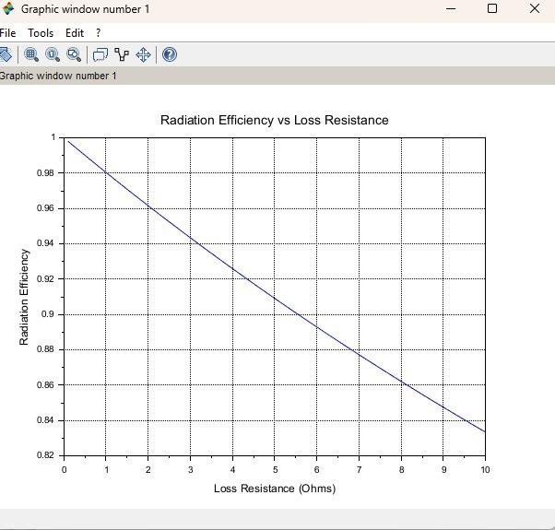
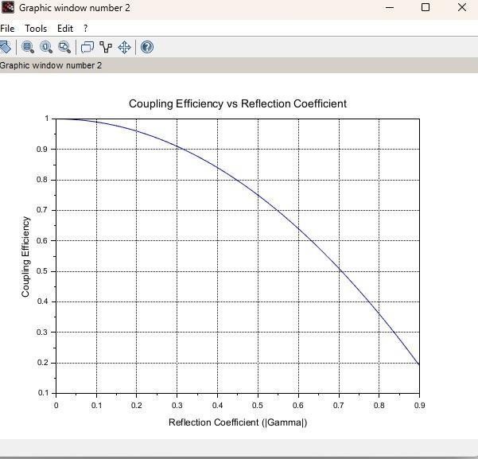
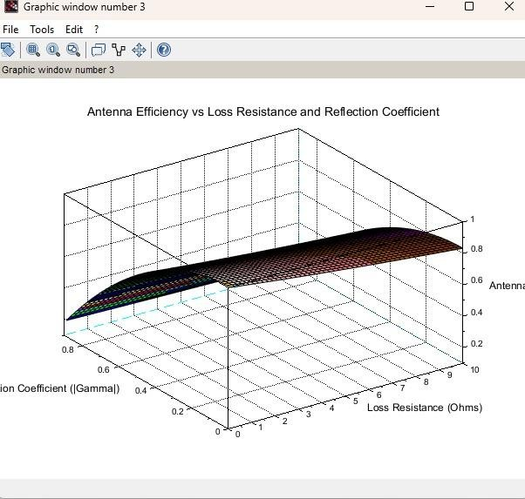

RESULT:
The experiment was done and the efficiency of the given antenna was found. Different case studies were analyzed. These case studies highlight the practical importance of antenna efficiency in various applications. For all systems, increasing radiation efficiency (minimizing power loss) and coupling efficiency (ensuring impedance matching) were crucial for optimizing antenna performance. The calculations show that, for practical systems, small improvement

